‘Beyond Sensitivity’: Understanding caregiving compromises in adverse contexts using the Meaning of the Child Interview
Ben Grey
https://orcid.org/0000-0003-3511-561X
Pre-publication draft – please cite as:
Grey, B (2023), ‘Beyond Sensitivity: Understanding caregiving compromises in adverse contexts using the Meaning of the Child Interview’ in Chrzastowski, S & Vetere, A eds. ‘Safety, danger, and protection in the Family, Community, and the World: A systemic and attachment-informed approach’, London and New York, Routledge
https://www.routledge.com/Safety-Danger-and-Protection-in-the-Family-and-Community-A-Systemic-and/Chrzastowski-Vetere/p/book/9781032311104

Abstract
Attachment theorists have frequently highlighted the adaptiveness of so called ‘insecure’ patterns of attachment to adverse and unsafe contexts, but the same understanding has rarely been extended to ‘insensitive’ caregiving. Caregiving has often been seen in linear, good/bad terms, as the ability or otherwise of the parent to provide a safe-haven to the child. Without development, this understanding of parental caregiving loses the potential of attachment theory to highlight the challenges posed by the external context in which a parent seeks to protect their children, and the ways this shapes the internal meaning the parent gives to their caregiving experiences. In this chapter, the Meaning of the Child Interview (MotC) is used to develop an understanding of non-sensitive caregiving as a series of implicit and explicit compromises that parents make to safeguard their child and manage the outside world. These compromises that are informed by their past and present experiences of danger, including the threats inherent in unequal social conditions and power relations, and contain both child-protective and self-protective elements. A case example based on interviews with parents of a child with a diagnosis of autism and his brother is used to illustrate the systemic and clinical potential of the theory.

Introduction
“Attachment theory is at its core a theory emphasising the importance of sensitive caregiving” (Forslund et al., 2021, p. 31).
Mary Ainsworth’s role in highlighting and evidencing the role of parental sensitivity as the bedrock of child attachment (Ainsworth et al., 1978/2015) was revolutionary in the context of an academic environment and wider culture saturated in behaviourism, which virtually equated sensitive responding with spoiling children (Grossmann et al., 2013). However, its subsequent influence in child welfare settings has created the risk that attachment theory can be used in a one-dimensional way to blame parents and obscure the contribution of social context to relational ‘insecurity’ and developmental difficulties in children (White et al., 2020). Such misuse, however, ignores the contribution of attachment theory in understanding how human relationships adapt and survive dangerous environments (Crittenden 2016), which, as Bowlby recognised includes the social and material conditions in which parents seek to care for their children (Duschinsky 2020).
This chapter develops these insights in relation to the Meaning of the Child interview (MotC: Grey & Farnfield, 2017), a procedure for analysing parenting interviews, and a case example of a family struggling with the behaviour of their 6-year-old child who has a diagnosis of autism, to show the potential of attachment theory to link internal meaning making with both past and present context. The MotC was developed within clinical practice, seeking to use the potential of attachment theory not just to label risk in vulnerable families, but to understand better the relationships of those who are struggling.

Parental Sensitivity
Bowlby’s systemic insights notwithstanding, conceptualisations of parental sensitivity have largely focussed on whether the parent is providing the foundations of secure attachment, despite the recognition that ‘security’ is not always optimal in all situations. For example, Forslund et al.’s (2021, p. 18) influential consensus of prominent attachment researchers, notes that diverse, even insecure, patterns contribute to a child’s “survival and adaptation to varying caregiving and contextual conditions” given that resources and adversity are not distributed equally. However, these writers (p. 30) define the assessment of caregiving in terms of “safe-haven provision”:
“The parent’s ability to understand and respond effectively to the child’s needs, to know and value the child, and to be consistently in charge in the relationship”.
This definition returns attention very squarely to an ability that resides in the parent rather than to the “varying … contextual conditions” in which secure attachment may not be adaptive. For example, trusting that others will respond empathically to an open communication of your frustrations may be dangerous in some relationships in so-called safe societies, let alone more obviously dangerous ones. If ‘insecure’ attachment strategies may be adaptive to difficult contexts, then the same must be true for parenting. Different and ‘non-sensitive’ patterns of caregiving, which may not offer a “safe-haven”, may be adaptive in adverse circumstances; they may prepare the child to manage dangerous environments where there is no true ‘safe haven’ for anyone, adult or child. Such caregiving might also enable the parent to continue to parent as best they can with minimal resources.
This chapter suggests that compromised caregiving may better capture the active way in which parents interact with their particular context to offer the best chances to their offspring, whilst enabling parents’ continuing functioning and management of their wider relationships. Acting upon limited information, parents prioritise and respond to aspects of reality that have informed their survival and ability to manage the particular dangers that have loomed large in their experience. That is, their actions are based on an interpretation of their current context through the lens of their past (Crittenden 2016). In addition, parents need to continue to survive and function in order to continue to care for their child, or in extremis, raise other children. Whether explicitly acknowledged or not, all parents to a greater or lesser extent face a trade-off between their own survival needs and the caregiving impulse to ensure the survival of their offspring. Given the importance of adequate parental functioning to the survival chances of the child, this dilemma can become acute in dangerous situations and environments.

The Caregiving Motivational System
Bowlby envisaged the parental caregiving system as the mirror image of the child attachment system (Duschinsky 2020). Child attachment was conceived as staying safe by regulating proximity with the attachment figure. The caregiving system was based on the retrieval instinct of the caregiver: how far can the parent “let the child go” and explore the world, whilst still being able to remove the child from trouble when needed. Especially as the child gets older and the immediate physical presence of the caregiver becomes less important, retrieval and proximity are better seen as metaphors for the regulation of parental availability. Specifically, what level of psychological availability and attentiveness is needed to reassure the child that the parent can offer protection and support when needed, and the parent that the child will fall in quick enough with this to ensure his or her safety? The parent balances their instinct to protect the children with the child’s need for independence and a concern for their wider development, and the parents’ need to negotiate the world around the child.

Adaptive Caregiving Strategies
However, weighing up these goals in particular contexts, with shifting danger and our necessarily limited perspective on reality, is a more complex business. In the real-world, human beings need to make compromises in order to react quick enough to protect themselves and their young. From the child’s point of view, Ainsworth’s work began to formally outline the 2 basic defences or compromises for the child, namely Type A (commonly called avoidant) attachment, where the child keeps a level of distance, particularly emotionally, in order to remain close enough to the attachment figure for protection whilst minimising the chances of rejection, and Type C (commonly called ambivalent), where the child seeks to ensure continuing closeness to a parent whose availability is uncertain, often by engaging in a continuous struggle with the attachment figure (Ainsworth et al., 1978). George and Solomon (2008) extended this approach to caregiving, identifying the mirror patterns in parents of “distanced protection”, where the caregiving system is deactivated, and the umbilical cord stretched (called here Unresponsive, or child-led parenting), and “close protection” (Controlling, or parent-led parenting), where the child is kept on a metaphorical short leash. There is a third option of “flexible” caregiving (here Sensitive, or collaborative parenting): trying to stay open to the situation and select the best option in the moment, attending when the child needs help, and facilitating independence when the child can manage. The Meaning of the Child Interview (MotC) terms of Sensitivity, Unresponsiveness and Control are drawn from Crittenden’s CARE-index (Crittenden, 2007). The CARE-Index operationalises Ainsworth’s thinking on parental sensitivity in a short, videoed episode of parent-infant play. Critically, it examines parent-child interaction dyadically, in terms of how child and parent behaviour are connected (or not) to other, rather than conceptualising sensitivity as an individualised trait or capacity.

Compromised Caregiving in the MotC
Without losing the focus this work gave to the representational world of the parent, we wish to link it further with the parents’ participation in the outside world, making explicit the external context in which these relationship patterns are situated. We will focus on Unresponsive and Controlling patterns, as the child-protective intentions and positive aspects of the compromises these parents are making are less intuitively obvious, and less frequently stressed.

Controlling, Parent-led Caregiving
Parents using a controlling strategy of caregiving devote resources to keeping the child in line and attentive to them and are hyper-aware of the dangers the world presents to the child, seeking to ‘make sure’ that they are able to protect the child. For this reason, it is a parent-led strategy of caregiving. The child’s separateness is experienced as threatening of the parents’ ability to protect the child. Parent-led caregiving tends to implicitly assume or explicitly state that the world is a hostile place that their child cannot manage alone. There is an assumption that the parent alone can offer the child what they need. If the parent does not (micro)manage the child and their environment, they (and the family) may get hurt. If the child is overly differentiated or separated from the parent, s/he may get ‘picked off’ by outside threats.
The key parental role is to monitor and maintain the child’s close alignment to the parent, so that the parent can always be on hand to ensure their safety. This can be done either by selectively focussing on countering the child’s attempts to individuate, seen in frustration or even hostility towards the child, or selectively emphasising their closeness and connection (how they are the same) blurring the gap between parent and child in ways that may seem enmeshed.
The advantage of this strategy is that the parent can be always ‘on-hand’ to deal with any threat posed to the child and can tackle problems that the child cannot manage alone. The parent is more equipped than the child to manage the world and better able to make sure of their safety. This is a (nearly) “always on” strategy – activated quickly and terminated slowly. The fear of the child struggling, failing, missing out, or getting themselves in trouble is highly motivating, such that parents remain actively monitoring the child and situation, even when the child is safe. That way they can be ready for problems and dangers as they arise. For the child, it can be reassuring to have so much parental availability, attention, and ultimately protection.
The difficulty or risk is firstly that this is potentially overwhelming for the parent, leaving them depleted in their ability to attend outside of the relationship. This can cause resentment in the parent (which the child may also pick up on). Such resentment can fuel the negative side of the strategy, where alignment with the parent is enforced more punitively or emotively (either through harsh parenting, or emotional plays for increased closeness). This pressurises the child not to differentiate in any way that might put them at risk from the parent as well as the outside world. Secondly, the pattern necessarily involves rejection of the child’s separate self, potentially negatively impacting the child’s sense of their own competence and value.

Unresponsive, child-led caregiving
Parents using an unresponsive strategy intuitively recognise that they cannot always be around to protect their children who will need to learn to manage without them. They may devote more resources to managing the world outside the family, telling themselves not to ‘interfere’ with the child’s development and independence. It is a child-led strategy; children are seen as possessing what they need to develop, so long as the parent manages the outside world and doesn’t inflict their own needs on their offspring. The parent-child umbilical cord is stretched as far as it will go to facilitate maximum independence and free up the parent to attend to dangers outside the parent-child relationship. Parents tend to implicitly assume that their child knows best and can handle situations themselves better using their own resources, which it is essential that they develop and utilise. There is a corresponding distrust in what the parent has to offer the child.
The key parental role is to hasten the child’s ability to manage by themselves. This may lead to a prioritisation of encouraging competence (e.g., educational achievement or learning practical skills) over nurture (attending to the child’s feelings or experience). Nurture may lead to dependence upon the parent, whilst competence helps the child manage the world successfully.
The advantage is that the strategy allows the parent to attend to other threats and their own functioning – facilitating the child’s developing her/his own independent resources, and rationing their availability to the child for when it is really needed. The caregiving system is activated late and terminated early, conserving resources. For the child, the strategy offers increased opportunities for self-mastery and independence.
The difficulty or risk is that the child will also experience a lack of nurture, support, connection, and potentially a felt or real lack of protection. The more the parent attends away from the child, the less quickly they are able to respond to sudden and unexpected threats to the child or serious distress. This can leave the child dealing with threats and problems they cannot manage despite the parents’ better intentions. Even where the child is safe, because the parent is elsewhere a lot of the time (psychologically if not physically), much of the child’s world remains invisible to the parent, and so by extension to the child also. Lacking an effect upon others, such children can at worst become invisible to themselves – and struggle to develop a coherent or complete sense of self. They can gain a superficial competence, but one that is externally defined and motivated by social rules or powerful others.

Self-protection vs. Child-protection
The evolutionary function of attachment is to stay alive long enough to reproduce and pass on your genes (Crittenden 2016). However, these two goals can and often do conflict – i.e., the impulse to nurture and protect the child, can conflict with or threaten the parent’s impulse to survive. Whilst in extremis, parents may sacrifice themselves to save their children, all or most parents experience a competing impulse to protect themselves (and go on to raise other children), rather than risk no-one surviving and no future offspring. In practice it is difficult to disentangle these two instinctive responses. We are likely to dress up self-protection in terms of child-protection to avoid being shamed, and because sometimes we do need to prioritise ourselves as parents to keep our children safe.

The Social Context of Caregiving
It is here that critical differences between the attachment and caregiving systems become clear. For the child (especially the infant) the parent is (for the most part) their whole world. Whilst age introduces a wider and more complex set of relationships, until adolescence these are largely mediated through the parent. However, the management of the outside social world and other relationships for the child is integral to parental caregiving in a way that it is not for child attachment, for whom ‘management’ only of the parent and other key relationships are key.
This means that to truly understand caregiving we need to understand the historical and social context in which the parent is situated, along with the cultural discourses parents use to give meaning to their experience and the power-relationships that inform them. It can be useful to think about these as a series of embedded circles containing and shaping the basic parent-child relationship, informing every aspect of it (Figure 1):
Figure 1: The embedded Meaning of the Child
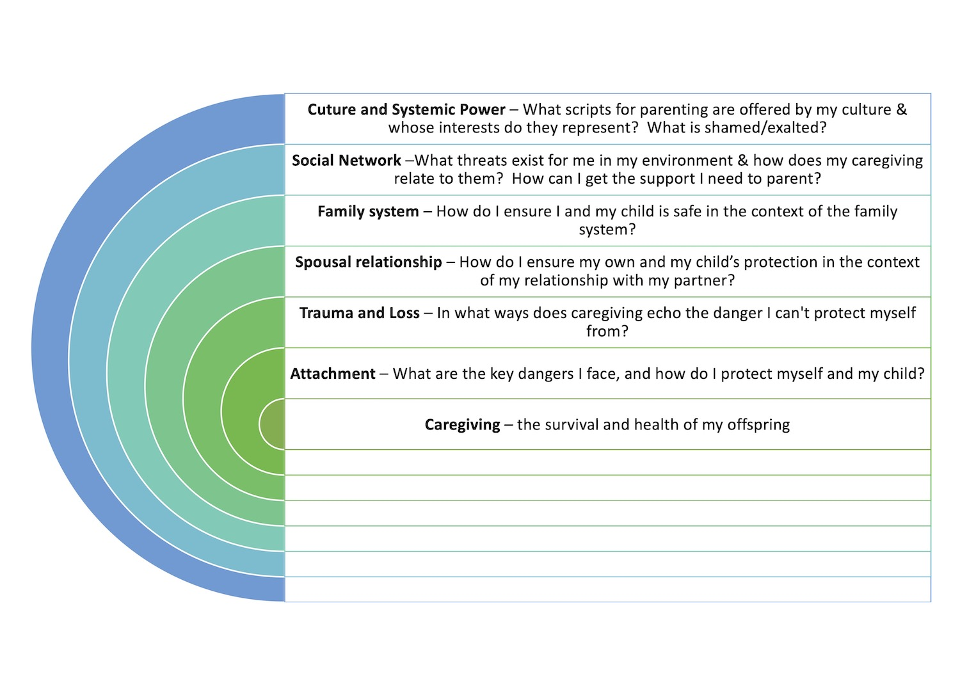
In one parent-child relationship, managing the tensions in the spousal relationship may be so critical to the safety of mother and child, that this is what primarily informs the caregiving pattern, but this is also mediated by the wider social situation, which informs those tensions. For example, a mother’s attention is so devoted to managing her frequently violent partner (who in turn protects her and her child perhaps from a very dangerous external gangland, violence-dominated, social context), that she has little parental resources remaining for the comfort and wider protection of her child. This, at least from her perspective, may be the best compromise she can make in the current circumstances (even if her pattern is classified as unresponsive). Her partner may be hypervigilant to challenges to his authority, and feel he must assert power and dominance, and to ‘make sure’ his child and partner toe the line (so he can protect them), as this may be his best chance of fighting off an ever-present danger of physical attack and potential exploitation (even though this compromise would be classified as controlling). Cultural narratives encouraging women to organise their identity around pleasing their spouse, and men to see their value in terms of their strength and status outside the home, socially sanction the mother sacrificing her own and her child’s safety, and the father’s aggressive ‘protection’ of the family status. They also make the process less visible by normalising it. Context is key to understanding the meaning of caregiving for each parent.

Case Example
The following example is drawn from the interviews of two parents of a child with a diagnosis of autism. The family was part of a wider study of families who have a child with this diagnosis, and a multi-family intervention aimed at supporting them (Dallos et al., 2022; Grey et al., 2021). In these studies, we looked at how parental trauma can transform how problems are maintained and intensified in the lives of the families where a child had an autism diagnosis. We also drew attention to how the social discourse around autism, by locating relational problems entirely as an individual irreversible disorder, helped ease the sense of blame felt by the parents we studied, but also robbed them of much of their interpersonal influence as a parent. Parent-child interaction was stripped of any relational and personal meaning, being seen only as a ‘symptom’ of autism. Parents were left managing dysfunctional behaviour rather than relating to their children. In this chapter, our focus is on the contextual nature of parental caregiving however, rather than the difficulties presenting around autism.

Family Context
Dave and Denise, live with their two sons, Jim (aged 6) and Ollie (aged 4). Denise’s side of the family live nearby and see them regularly.

Parental Attachment and Caregiving
Dave: Feeling “on a prison ship”
Dave describes a family history as “quite a happy childhood” but a father prone to anger, and a mother whose attention was devoted to Church activities. Dave noted that “in my childhood we did have a lot of running around after other people and us feeling slightly neglected” but commented: “I like the way she's like really caring for other people”.
Dave’s mother’s strict and socially isolating kind of religion placed him in situations where he felt humiliated and trapped:
[My] mother was a constant embarrassment, to be honest … one day I'm going to be free of this woman, I can start living.’
Unfortunately, Dave’s experience of being a parent is exchanging one kind of imprisonment for another:
You just feel hemmed in like you're … on a ship, a prison ship or something, trapped with them and you can't get away and it's all a bit much and you're trying to drive a car and they're like (makes wailing noise), and you're like can't take any more of this my head's gonna pop.

The over-riding theme of Dave’s MotC is a sense of feeling trapped in the relationship with Jim. He tries to avoid getting angry with Jim and this is at some cost to him. He describes that he feels shaky and upset after Jim’s “meltdowns” and that he has to use anti – depressants to cope. In MotC terms, this is unresponsive, ‘child-led’ parenting, seeing himself as a threat to the child and aiming not to impose his feelings on his child like his father did. He hankers after an outdoor, ‘free’, activity-based and without the kind of claustrophobic intensity of his own childhood, but his desire to be a good parent places him right back in the same situations of being socially shamed that his mother placed him in:
I was in Homebase today, and a lady had a young lad … and he was … playing up around the shop and stuff, … whizzing around say, on the wheelie thing … and I just thought, he's just got autism.
Therefore, although Dave is working hard to be more in control of his temper than his father, his desperation to break-free results in lapses that intensify his feelings of shame:
I couldn't control it, … just feeling like, you know, I should be controlling this, I should be a parent, that sort of stuff, putting myself under pressure, but it is what it is really.

Thinking in terms of the social context, the discourse of autism is employed by Dave’s unresponsive pattern to strip away the personal rupture inherent in his conflict with his son (“it is what it is really”), by removing his and his child’s behaviour from any relational or interpersonal context (“he’s just got autism”). His child is a “locked inside his own head” and unreachable – so separate, Dave feels unable to act as a parent to Jim:
there's lots of people with mental illness and autism and they're all sort of locked inside their own head and stuff… you feel you're just not getting through to him.
This has the effect of making the whole problem feel inevitable and irresolvable – for Dave, there is no escape.
Denise: “Fighting a Fire”
A significant part of Denise’s childhood had been that her brother suffered from mental health problems, which continue to impact on Denise’s life and that of her parents. Denise’s interview tended to minimise difficulties and portray her childhood as happy, although showing an undercurrent of fear not fully acknowledged. Denise was the ‘good’ child, with a twin brother who had constant problems:
Once my brother just kinda flipped out a bit about something around his anxiety, and I think he, he did break my mum's glasses once, um I think I was there, and I remember sort of thinking, it was a bit upsetting to see your parent, you know, being sort of attacked because you know you want to see that they're all together and they’re fine … but on the whole he would actually be sort of violent, that would make us feel unsafe, though um it was more just sort of this anxiety, and … he was more sort of shy with it on the whole rather than kind of very angry with it.
Denise’s language is minimising (“bit upsetting”, “flipped out a bit’” “more sort of shy”) but there is an undercurrent of fear and danger (“flipped”, “attacked”, “violent”), which she is reluctant to stay with, perhaps because to focus on her vulnerability and fear might overwhelm her, and undermine her role of being the supportive, helpful one who holds everything together.
Significantly, Denise appears to be repeating the same role in her parenting, in that she is trying to hold things together by focussing on her task rather than her feelings, and is not able to draw any hope of things getting better from her own family:
it can feel a bit like fighting fire sometimes because it's kind of desperation because … literally things are starting to fly around and get broken, and you think um someone is really going to get hurt or something is really going to get broken in a minute, and you have to sort of drop everything and whatever you’re doing and sort of calm things down um so um it can just make you feel a bit frazzled (laugh)
There are a range of adversarial images of it being a “battle”, “struggle”, “fighting a fire”, “like a roller coaster” in ways that echo the unresolved sense of danger from her own childhood. At the same time Jim is not personally present in this picture (notice that “someone” and “something” will get hurt or broken, without anyone particular doing these things). Denise is only present in the more distant “you”, and with the emotional impact minimised (“sort of calm things down”; “a bit frazzled”). Like Dave, she appears to have developed a way of distancing from Jim. The socially provided autism discourse helps to ameliorate her anger, by externalising the problem as “autism” rather than Jim personally, and recruiting her childhood role as the family fire-fighter, the one who “calms things down”. However, at the same time it renders Denise external to the situation, trying desperately to predict what he will do next and running after him, as if he were an out-of-control missile, rather than seeing herself as participating in a relationship with her son. She is “desperate”, because in re-enforcing her child-led, unresponsive strategy, Denise is not present as a parent with a power to influence and resolve the conflict and ruptures in her family, until she comes in from the outside, “fire-fighting’” to “calm things down”. The metaphor is telling, as fire fighters have no part in fire itself, or the circumstances that led to it, but are external and can only arrive once things are already out of control.

Family relationships: “A battle … you just can’t control”
Whilst both parents frequently mention the stress and strains of parenting there is very little reference to either of them seeking support from the other. It seems the core of their shared experiences is that Jim is frustrating, like a battle, promoting a sense of helplessness and exhaustion. However, both parents described problems situated within family processes which actively involved Ollie, Jim’s sibling, who does not have an autism (or any other) diagnosis:
They'll feed off each other like Jim'll react to Ollie, Ollie will get in a state, Jim won’t like the noise, Jim'll kick off and then Ollie will just um react to that and you just can't control the situation (laughs), you just got to ride it out and stuff.
The children are seen as feeding of’ each other, a typical family process. However, for Dave and Denise, instead it is Jim’s autism that is the problem, and that there is nothing you can do about it but try and “ride it out”.
For Jim and Ollie their central experience of such a child-led pattern, must be their parents’ constant fear of them; a sense of being too powerful, of being uncontained, unprotected, and uncomforted. This could lead to them exacerbating their difficult behaviour to draw their parents in to “drop everything” and “try and calm things down”. By becoming angry, the children would feel more powerful and in control of a fearful world. This partially succeeds in drawing in the parents to manage them physically but exacerbates the fear of their parents (Dave that he will lose control of himself, and Denise that she will lose control of the family situation), adding fuel to the fire. The children are only partially reassured by their parents containing behaviour, as their high arousal is not addressed or seen, perpetuating the cycle.
Looking at all of this, the embedded MotC (Figure 1) for Denise and Dave can be more specifically written as Figure 2, below.
Figure 2: Dave and Denise’s embedded MotC
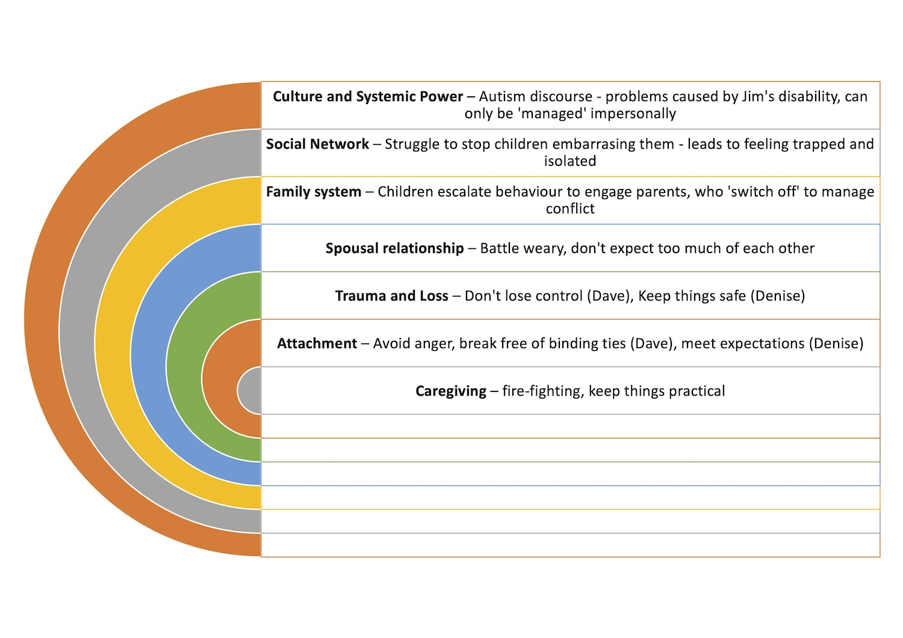

Conclusion
Our analysis of Dave and Denise’s situation shows an overly child-led family system, as the parents must try and switch off emotionally to manage the family conflict, and the children escalate behavioural attempts to be seen and engage their parents. However, this unresponsiveness is motivated ‘from below’ by Dave’s fear of losing it like his father and being trapped by closeness to his mother, and Denise’s role of avoiding her feelings to manage the conflict in her family origin. It is also entrenched ‘from above’ by the culturally available discourses about autism, which by locating the problem as an impersonal and individualised brain impairment not as “naughtiness” (an internal motivation). This robs the children’s behaviour of any interpersonal significance, likely intensifying Jim and Ollie’s sense of not being seen. For Dave and Denise, these discourses help them manage the social embarrassment and potential blame in caring for Jim, as well as avoid angry feelings that might (and for Dave sometimes do) overwhelm them. However, these compromises leave them trapped and desperate, as there is no room in this for parental influence, the ability to make things different by helping manage and contain their child(ren)’s feelings.
The example helps illustrate how attachment and caregiving analysis of discourse, whilst illuminating internal representations, do not make parental sensitivity and internal capacity of the parent, but a feature of a wider social network, incorporating a present context as well as past history. Unresponsiveness and Control are compromises that parents instinctively as well as consciously make to find what passes for safety in dangerous contexts, whilst holding themselves together in the meantime. Without losing awareness of the impact upon children, this kind of analysis can make these compromises explicit, highlighting both the ‘payoff’ that keeps the system going, as well as the price being paid by each member of the family, which might be too high. It draws attention to the external dangers in the past and present social environment that may be sustaining such compromised caregiving. This potentially opens the way for collaborative intervention in finding alternatives or possibilities for change that might otherwise be invisible.
References
Ainsworth, M., Blehar, M., Waters, E., & Wall, S. (1978/2015). Patterns of attachment: A psychological study of the Strange Situation. Erlbaum.
Crittenden, P. M. (2007). CARE-Index: Infant and toddlers coding manual. Unpublished manuscript, Family Relations Institute
Crittenden, P. M. (2016). Raising parents: Attachment, representation, and treatment (2nd ed.). Routledge.
Dallos, R., Grey, B., & Stancer, R. (2022). Anger without a voice, anger without a solution: Parent–child triadic processes and the experience of caring for a child with a diagnosis of autism. Human Systems, 26344041221115256. https://doi.org/10.1177/26344041221115255
Duschinsky, R. (2020). Cornerstones of Attachment Research. Oxford University Press. https://doi.org/10.1093/med-psych/9780198842064.001.0001
Forslund, T., Granqvist, P., van IJzendoorn, M. H., Sagi-Schwartz, A., Glaser, D., Steele, M., Hammarlund, M., Schuengel, C., Bakermans-Kranenburg, M. J., Steele, H., Shaver, P. R., Lux, U., Simmonds, J., Jacobvitz, D., Groh, A. M., Bernard, K., Cyr, C., Hazen, N. L., Foster, S., … Duschinsky, R. (2021). Attachment goes to court: Child protection and custody issues. Attachment & Human Development, 1–52. https://doi.org/10.1080/14616734.2020.1840762
George, C., & Solomon, J. (2008). The caregiving system: A behavioral systems approach to parenting. In J. Cassidy & P. Shaver (Eds.), Handbook of attachment: Theory, research, and clinical applications (Vol. 2nd, pp. 833–856). Guilford Press.
Grey, B., Dallos, R., & Stancer, R. (2021). Feeling ‘like you’re on … a prison ship’ – Understanding the caregiving and attachment narratives of parents of autistic children. Human Systems, 26344041211000200. https://doi.org/10.1177/26344041211000202
Grey, B., & Farnfield, S. (2017). The Meaning of the Child Interview: A new procedure for assessing and understanding parent–child relationships of ‘at-risk’ families. Clinical Child Psychology and Psychiatry, 22(2), 204–218. https://doi.org/10.1177/1359104516633495
Grossmann, K. E., Bretherton, I., Waters, E., & Grossmann, K. (2013). Maternal sensitivity: Observational studies honoring Mary Ainsworth’s 100th year. Attachment & Human Development, 15(5–6), 443–447. https://doi.org/10.1080/14616734.2013.841058
White, S., Wastall, D., Matthew, G., & Walsh, P. (2020). Reassessing Attachment Theory in Child Welfare. Policy Press; 1st edition.

